**Automation and Continuous Updating**

**1. Introduction**: This section emphasizes the importance of continually updating data sources to maintain information accuracy. It outlines the methodology for automating data source management.

**2. Data Source Monitoring**: The system utilizes continuous monitoring to identify changes in data sources, including new data or modifications. Monitoring triggers data update processes.

**3. Automated Data Retrieval:** Automated processes are triggered upon detecting changes, utilizing APIs or web scraping to fetch data in real-time or at scheduled intervals.

**4. Data Processing and Standardization:** Fetched data undergoes processing to ensure compatibility and consistency with existing datasets. This includes cleaning, filtering, and structuring to meet quality standards.

**5. Update Triggers and Scheduling**: Triggers and scheduling tools automate data update timing based on specific conditions or predefined intervals. cron jobs or task scheduler are employed for execution.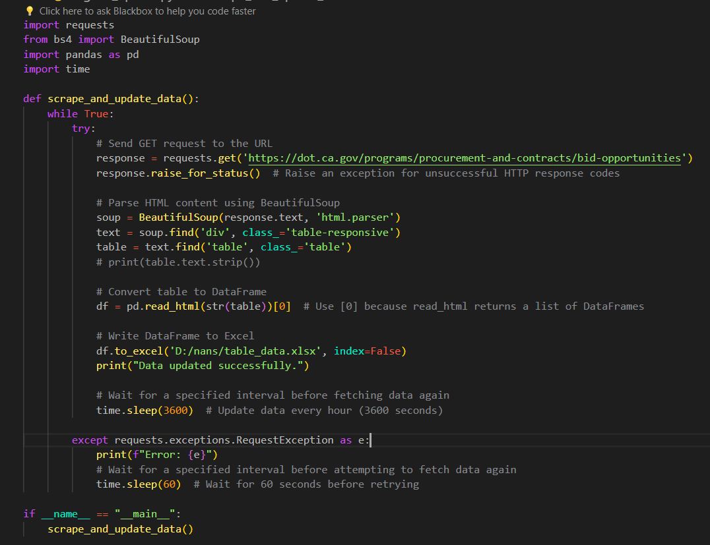

**Figure 1 code of automate updation**

USE OF CRON JOBS:

1. **Automation:** Cron jobs automate the execution of data update tasks according to a specified schedule. This eliminates the need for manual intervention, reducing human error and ensuring that data updates occur consistently and reliably.
2. **Scheduled Execution:** With cron jobs, users can schedule the execution of data update scripts or commands at specific times or intervals. For example, a cron job can be set to run a Python script every hour, every day, or at other customized intervals based on the organization's requirements.
3. **Flexibility:** Cron jobs offer flexibility in scheduling, allowing users to define custom intervals for data updates. This flexibility enables organizations to tailor the update frequency to match the pace of data changes in their sources and the needs of their stakeholders.
4. **Resource Optimization:** By automating data update tasks with cron jobs, organizations can optimize resource utilization and streamline workflow processes. Instead of allocating human resources to manually execute data updates, cron jobs handle the task efficiently in the background.
5. **Error Handling and Monitoring:** Cron jobs typically provide mechanisms for error handling and monitoring. Users can configure cron jobs to send notifications or alerts in case of errors or failures during the execution of data update tasks. This allows for timely troubleshooting and resolution of issues to ensure uninterrupted data updates.
6. **Scalability:** Cron jobs are scalable and can be easily configured to accommodate changes in data update requirements or scale up to handle larger datasets. As data volumes grow or new sources are added, cron jobs can be adjusted accordingly to ensure continued smooth operation.